Section 1: Case Summary

Scenario Title: | TB Pericarditis
Keywords: | Pericarditis, Pericardial Tamponade, Tuberculosis
Brief Description of Case: | A 38 year-old man (Ethiopian refugee) with untreated HIV and past history of TB, presents to the emergency department (ED) with anterior chest pain, shortness of breath and hypotension. He was seen 3 days prior by a walk-in clinic and referred to the ED with chest pain and ECG showing pericarditis, but did not attend the ED until symptoms were severe. In the ED, patient quickly progresses to profound shock and has a PEA arrest. POCUS will show a large pericardial effusion and tamponade. Team members are to initiate CPR, manage the arrest and treat the effusion using bedside pericardiocentesis in order to obtain return of spontaneous circulation (ROSC).

Goals and Objectives
Educational Goal: | To diagnose and manage a case of pericardial tamponade causing PEA arrest.
Objectives:  (Medical and CRM) | CRM  - Demonstrate effective communication with the healthcare team  - Maintain situational awareness during a rarely performed procedure  Medical  - Work through the causes of shortness of breath in a young HIV positive patient  - Recognize the clinical features of pericarditis and pericardial tamponade  - Manage a PEA arrest that is triggered by pericardial tamponade according to ACLS guidelines and consider modifications to ACLS pertinent to this situation
EPAs Assessed: | N/A

Learners, Setting and Personnel
Target Learners: | ☒ Junior Learners |  | ☒ Senior Learners |  |  | ☐ Staff
 | ☒ Physicians | ☐ Nurses |  | ☐ RTs | ☐ Inter-professional
 | ☐ Other Learners:
Location: | ☒ Sim Lab |  | ☒ In Situ |  |  | ☐ Other:
Recommended Number of Facilitators: | Instructors: 1-2
 | Sim Actors: 1
 | Sim Techs: 1

Scenario Development
Date of Development: | 1/02/2018
Scenario Developer(s): | Drs. Alexandra Stefan and Marissa Lu
Affiliations/Institutions(s): | University of Toronto
Contact E-mail: | alexandra.stefan@utoronto.ca
Last Revision Date: | Sept 7, 2020
Revised By: | Drs. Quang Ngo and Chris Heyd
Version Number: | 2

Section 2A: Initial Patient Information

Clinical Vignette: To Read Aloud at Beginning of Case
“You are working in the acute area of the ED of a community hospital. You are called to assess a patient by the RN who is concerned about the patient’s respiratory status. You meet Mr. Tesfaye and his cousin; the patient is complaining of chest pain and severe shortness of breath.”

- Patient Chart
Patient Name: Mr. Tesfaye |  |  |  | Age: 38 | Gender: M | Weight: 55 kg
Presenting complaint: Chest pain and shortness of breath
Temp: 36.5ºC | HR: 130/min | BP: 90/60 |  | RR: 30/min | O₂Sat: 96% | FiO₂: RA
Cap glucose: 5.8 mmol/L |  |  |  | GCS: 15 (E4 V5 M6)
Triage note: Unwell for 1 week with chest pain (worse when lying, better leaning forward). Seen in walk-in clinic 3 days ago with ECG, told to come to ED but patient refused. Now worsening shortness of breath over past 3 days, cannot lie down and cannot walk. Looks unwell.
Allergies: NKDA
Past Medical History:  TB  HIV |  |  | Current Medications: None

Section 2B: Extra Patient Information

A. Further History
Include any relevant history not included in triage note above. What information will only be given to learners if they ask? Who will provide this information (mannequin’s voice, Sim Actor, SP, etc.)?

From patient’s cousin:

HPI: 1 week of progressive chest pain and shortness of breath, cannot lie down, went to walk-in clinic and was told to come to ED 3 days ago but did not go until today.

Medical History: TB treatment initiated by health clinic 2 years ago in refugee camp, patient never completed full course of treatment. Diagnosed with HIV 3 months ago during immigration screening, no treatment yet.

Social History: Refugee from Ethiopia, limited English; came to Canada 3 months ago

B. Physical Exam
List any pertinent positive and negative findings
Cardio: Sinus tachycardia, no peripheral edema, normal heart sounds.  JVP – cannot assess as too much accessory muscle use. | Neuro: Alert, oriented, pupils equal and reactive.
Resp: Respiratory distress, 2-3 word sentences; chest clear to auscultation, sitting upright. | Head & Neck: Nil acute.
Abdo: tender, non-distended. | MSK/skin: Nil acute.
Other:

Section 3: Technical Requirements/Room Vision

A. Patient
☒ Mannequin: Adult
☐ Standardized Patient
☒ Task Trainer
☐ Hybrid
B. Special Equipment Required
Critical care supplies
Airway equipment
Pericardiocentesis kit or large bore LP needle and large syringe
Bedside ultrasound
C. Required Medications
ACLS medications

D. Moulage
Dark skinned mannequin

E. Monitors at Case Onset
☒ Patient on monitor with vitals displayed
☐ Patient not yet on monitor
F. Patient Reactions and Exam
Include any relevant physical exam findings that require mannequin programming or cues from patient
(e.g. – abnormal breath sounds, moaning when RUQ palpated, etc.) May be helpful to frame in ABCDE format.

Unable to lie flat, will panic and gasp for air if supine

Section 4: Sim Actors and Standardized Patients

Sim Actor and Standardized Patient Roles and Scripts
Role | Description of role, expected behavior, and key moments to intervene/prompt learners. Include any script required (including conveying patient information if patient is unable)
Family member (cousin) | Provide past history of TB and HIV (if asked) as well as social history. Offer letter from walk in clinic and ECG.
Props | Letter from walk-in clinic with ECG: “Dear ED Physician, please urgently assess this young man with chest pain and ST changes on ECG.”
Bedside RN | Skillful and helpful.

Section 5: Scenario Progression

Scenario States, Modifiers and Triggers
Patient State/Vitals | Patient Status | Learner Actions, Modifiers & Triggers to Move to Next State |  | Facilitator Notes
1. Baseline State  Rhythm: Sinus tach  HR: 130/min  BP: 90/60  RR: 30/min  O₂SAT: 96% RA  T: 36.5ºC  GCS: 15 | Severe respiratory distress  States: “My chest is hurting”, “I cannot breathe”, “I have to sit up” | Expected Learner Actions  History from family member – family gives clinic note and ECG  Monitors, IVs, supplemental O₂  Initiate appropriate PPE  12-lead ECG  Give ASA 160 mg po  Bloodwork  IV fluid bolus  Ask for portable CXR  Ask for POCUS | Modifiers  - O₂ → mild relief of SOB but vitals do not change  - Fluids given → BP 100/60  - Morphine or Nitro → SBP 60 mmHg, patient becomes drowsy  Triggers  For progression to next state  All action complete or 6 minutes→ 2. Shock | Recognize and verbalize diffuse ST elevation consistent with pericarditis on first ECG and now low voltages suggestive of tamponade
2. Shock  HR: 140  BP: 60/30  O₂SAT: -- | Drowsy and confused, not answering questions | Call for cardiology consult  Additional fluid bolus  Consider vasopressors  POCUS assessment of shock  Identify large pericardial effusion with tamponade  Prepare for pericardiocentesis | Modifiers  - Vasopressor → no BP change  Triggers  3 minutes→ 3. PEA arrest | RN can prompt learner if missing diagnosis: “EKG interpretation says acute pericarditis, could it be that?”
3. PEA Arrest  Rhythm: Sinus tach  HR: 150  No palpable pulse | Not breathing  Not responsive | Start CPR while preparing for pericardiocentesis without delay of definitive management  Consider airway management (discussion of continuing BVM vs LMA vs intubation in this setting)  Epi 1mg q3 to 5min  Perform pericardiocentesis | Modifiers  Triggers  Pericardiocentesis→ 4. Resolution | (learners to describe how they would perform wither blind or ultrasound-guided)
4. Resolution  HR: 130  RR: 20  BP: 80/40  O₂SAT: 100% on NRB | Drowsy but rousable | Repeat head to toe exam and vital signs  Refer to ICU/CCU/Cardiology per local guidelines | End of scenario

Appendix A: Laboratory Results

No lab results during case

Appendix B: ECGs, X-rays, Ultrasounds and Pictures

Paste in any auxiliary files required for running the session. Don’t forget to include their source so you can find them later!
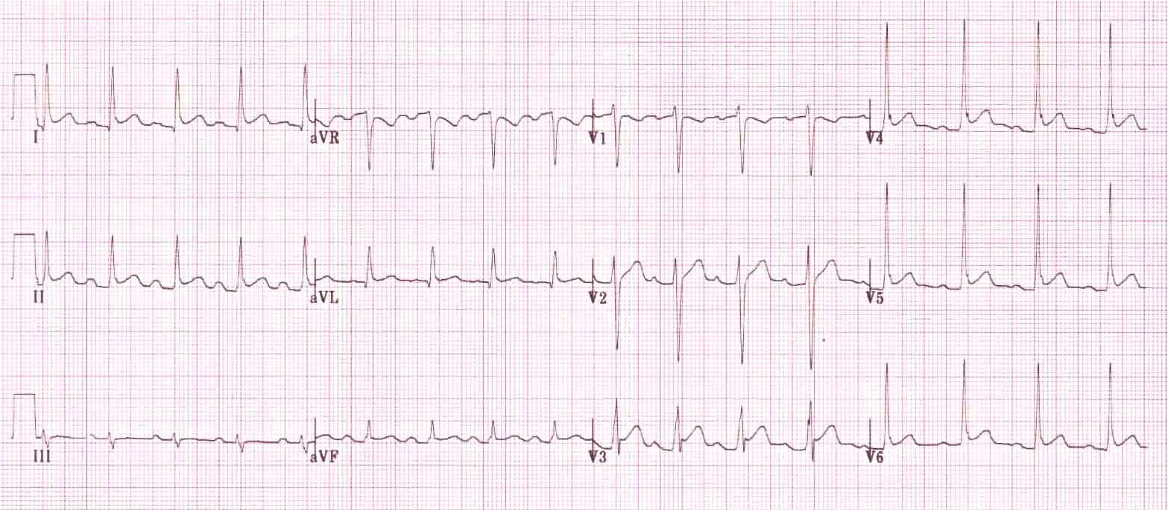
ECG from WIC Source: https://lifeinthefastlane.com/ecg-library/basics/pericarditis/

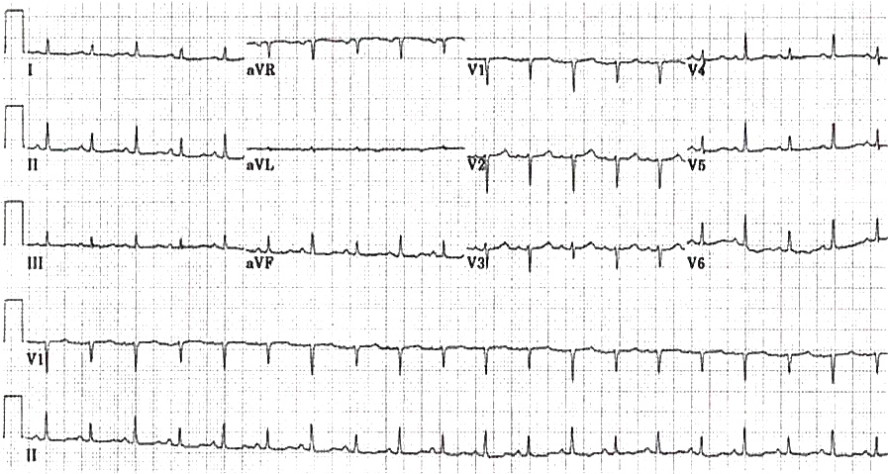
ECG in ED Source: https://lifeinthefastlane.com/ecg-library/electrical-alternans/
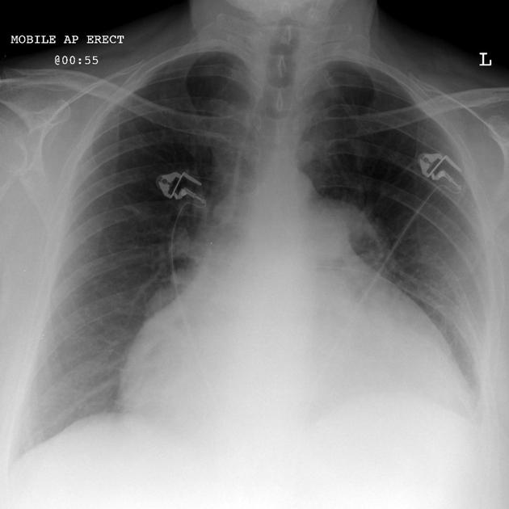
Source for CXR = https://radiopaedia.org/cases/pericardial-effusion-water-bottle-sign-2

Appendix C: Facilitator Cheat Sheet & Debriefing Tips

Include key errors to watch for and common challenges with the case. List issues expected to be part of the debriefing discussion. Supplemental information regarding any relevant pathophysiology, guidelines, or management information that may be reviewed during debriefing should be provided for facilitators to have as a reference.

Sample Questions for Debriefing
- What are possible causes of shortness of breath in a young, HIV positive patient?
- What are the priorities in the patient presenting with chest pain?
- What are causes of ST elevation on ECG?
- What are the ECG features of pericarditis? Of pericardial tamponade?
- What is the role of POCUS in assessment of patient with shock? What are causes of shock?
- What are the steps in a bedside pericardiocentesis?

Key Moments
- Identification of pericarditis on initial ECG and clinical history suggestive of tamponade
- Identification of pericardial effusion as cause of shortness of breath
- Initiation of CPR/treatment of PEA arrest with pericardiocentesis

Major debriefing points (Clinical):
- Recognition of sick patient
- Simultaneous assessment and initiation of resuscitation interventions (IV, supplemental O2, investigations)
- Timely 12-lead ECG in sick patient with chest pain
- Correct interpretation of ECG; review ECG findings of pericarditis (diffuse ST elevation, PR depression, lack of reciprocal changes, no ST elevation in aVR) and tamponade (low voltages)
- Role of POCUS in patient with chest pain and shock – the RUSH exam HI-MAP (heart, IVC, Morrison’s, AAA, pneumothorax)
- PEA arrest – timely CPR, epi 1mg and definitive management (pericardiocentesis) focus on good quality CPR and minimizing interruptions, prioritize setting up for treatment of underlying cause given PEA arrest
- Pericardiocentesis steps

Major debriefing points (Team Training):
- Mobilizing resources and assigning tasks in resuscitation
- Closed-loop communication during resuscitation of sick patient

References
1. https://www.ahajournals.org/doi/full/10.1161/circulationaha.105.543066
2. https://emergencymedicinecases.com/emergency-pericardiocentesis/
3. http://hivinsite.ucsf.edu/InSite?page=kb-04-01-05

